AI Infinite – Invoice & Passport Extraction System Documentation

1. Project Overview
AI Infinite is an AI-powered web application that extracts structured data from Invoices and Passports. The system uses Gemini 2.5 Flash for OCR and data extraction, and it provides outputs in JSON and Excel (XLSX) formats. The application requires users to create an account, after which they can access a dashboard to upload files.

2. Technology Stack
- Frontend: HTML, CSS, JavaScript
- Backend: Python, Flask
- Database: MySQL
- AI Model: Gemini 2.5 Flash (via API)
- File Support: JPG, JPEG, PNG, PDF (input) / JSON, Excel (XLSX) (output)

3. Application Flow
- User registers and logs in.
- User navigates to the dashboard.
- User uploads Invoice or Passport file.
- Flask backend sends file to Gemini 2.5 Flash API.
- AI extracts structured data and returns it.
- User downloads the output in JSON or Excel format.

4. How to Create the MySQL Database

4.1 Install MySQL
Install MySQL server and Workbench on your system.

4.2 Create Database
CREATE DATABASE invoice;

4.4 Initialize Tables
The following tables are created automatically if they do not exist:
- users
- contact_queries
- extraction_history
- api_keys
- api_usage
You can call init_db() in your Flask app startup to create these tables.

5. Configuring Flask Application

5.1 Install Dependencies
pip install flask mysql-connector-python google-generativeai openpyxl

5.2 Create Virtual Environment and Activate
After opening the AI Infinite project folder, run:

python -m venv venv # Create virtual environment
source venv/bin/activate # On Linux/Mac
venv\Scripts\activate # On Windows

5.3 Install Dependencies from requirements.txt

pip install -r requirements.txt

5.4 Configure Database Credentials in Flask
app.config['MYSQL_HOST'] = 'localhost'
app.config['MYSQL_USER'] = 'root'
app.config['MYSQL_PASSWORD'] = 'your_password'
app.config['MYSQL_DB'] = 'ai_infinite'

6. Gemini API Setup

6.1 Install SDK
pip install google-generativeai

6.2 Configure API Key
import google.generativeai as genai
import os

genai.configure(api_key=os.getenv("GOOGLE_API_KEY"))
model = genai.GenerativeModel("gemini-2.5-flash")

7. Extraction Logic

7.1 Invoice Extraction Prompt Structure
The system extracts:
- Invoice number
- Invoice date
- Vendor name
- Customer details
- Items list
- Tax details
- Total amount
- Payment info

7.2 Passport Extraction Output Format
{
"passport_number": "<Passport Number>",
"passport_type": "<Passport Type>",
"issue_date": "<Issue Date>",
"expiration_date": "<Expiration Date>",
"first_name": "<First Name>",
"last_name": "<Last Name>",
"middle_name": "<Middle Name>",
"date_of_birth": "<Date of Birth>",
"place_of_birth": "<Place of Birth>",
"gender": "<Gender>",
"nationality": "<Nationality>",
"passport_issuing_country": "<Passport Issuing Country>",
"passport_issuing_authority": "<Passport Issuing Authority>",
"passport_issuing_country_code": "<Country Code>",
"passport_holder_photo": "<Photo URL>",
"address": "<Address>",
"city": "<City>",
"state": "<State>",
"zip_code": "<Zip Code>",
"country": "<Country>",
"height": "<Height>",
"eye_color": "<Eye Color>",
"hair_color": "<Hair Color>",
"signature": "<Signature URL>",
"passport_barcode_data": "<Barcode Data>",
"emergency_contact": {
"name": "<Emergency Name>",
"phone": "<Emergency Phone>",
"address": "<Emergency Address>"
},
"visa_status": "<Visa Status>",
"visa_type": "<Visa Type>",
"visa_number": "<Visa Number>",
"visa_expiry_date": "<Visa Expiry Date>",
"visa_issuing_country": "<Visa Issuing Country>",
"visa_issuing_authority": "<Visa Issuing Authority>"
}

8. Supported File Formats

Uploads:
- JPG
- JPEG
- PNG
- PDF

Downloads:
- JSON
- Excel (XLSX)

9. Running the Application

9.1 Start Flask App
python app.py

9.2 Access in Browser
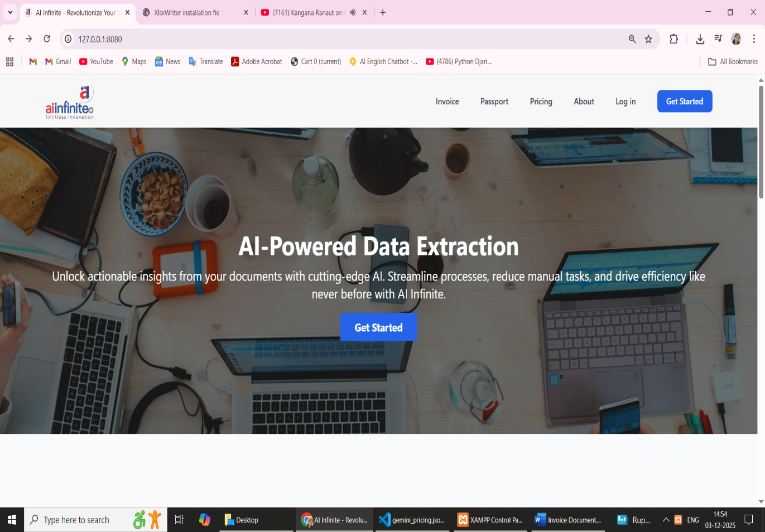
http://127.0.0.1:8080:

